**Supplementary Material**

**Functional replacement of the *Saccharomyces cerevisiae* fatty acid synthase with a bacterial type II system allows flexible product profiles**

**Ruben Fernandez-Moya1, Christopher Leber1, Javier Cardenas1 and Nancy A. Da Silva1\***

1 Department of Chemical Engineering and Materials Science, University of California, Irvine, CA, USA 92697-2575

**\* Corresponding author**

**Table S-1.** List of genes, proteins, and reactions.

|  |  |  |  |
| --- | --- | --- | --- |
| **Gene** | **Protein** | **Reaction** | **Ref.** |
| ***acpP*** | Acyl carrier protein (ACP) |  | White et al., 2005 |
| ***acpS*** | ACP synthase | apo-ACP + 4'-Phosphopantetheine Group 🡪 ACPSH | White et al., 2005 |
| ***fabB\**** | β-ketoacyl-ACP synthase I | (n)acyl-ACP + malonyl-ACP 🡪 (n+2)β-ketoacyl-ACP | White et al., 2005 |
| acetoacetyl-ACP + malonyl-ACP 🡪 β-ketobutyryl-ACP + CO2 + ACPSH |
| ***fabD*** | Malonyl-CoA:ACP transacylase | malonyl-CoA + ACPSH 🡪 malonyl-ACP | White et al., 2005 |
| ***fabG*** | β-ketoacyl-ACP reductase | β-ketoacyl-ACP + NADPH + H+ 🡪 β-hydroxyacyl-ACP + NADP+ | White et al., 2005 |
| ***fabH*** | β-ketoacyl-ACP synthase III | malonyl-ACP + acetyl-CoA 🡪 acetoacetyl-ACP | White et al., 2005 |
| ***fabI*** | Enoyl-ACP reductase | enoyl-ACP + NADH+H+ 🡪 acyl-ACP + NAD+ | White et al., 2005 |
| ***fabZ***† | β-hydroxyacyl-ACP dehydratase | β-hydroxyacyl-ACP 🡪 enoyl-ACP + H2O | White et al., 2005 |
| ***tesA*** | Thioesterase I | acyl-ACP 🡪 free fatty acid + ACPSH | Cho and Cronan, 1993 |

* Two *E. coli* enzymesFabB (β-ketoacyl-ACP synthase I) and FabF (β-ketoacyl-ACP synthase II) catalyze the condensation of malonyl-CoA with the fatty acyl-ACP growing chain. We expressed only β-ketoacyl-ACP synthase (FabB), since expression of FabF in active form has proven challenging (Magnuson et al., 1995).

† There are two genes in *E. coli* that encode β-hydroxyacyl-ACP dehydrases, FabA and FabZ. The broad substrate specificity of FabZ and the low activity of FabA for β-hydroxybutyryl-ACP (Heath and Rock, 1996) made FabZ a better choice for our work.

**Vector and strain construction**

*E. coli* strain XL1-Blue (Stratagene, Santa Clara, CA) was used for plasmid preparation and storage. *S. cerevisiae* host strain BY4741 (Open Biosystems, Huntsville, AL) was used for *in vitro* and *in vivo* studies. Standard molecular biology procedures were carried out as described in Sambrook and Russell (2001). Restriction enzymes, T4 DNA ligase, Taq DNA polymerase, and deoxynucleotides were purchased from New England Biolabs (Ipswich, MA). KOD Hot-start DNA polymerase was obtained from Novagen (San Diego, CA). Oligonucleotide primers were purchased from IDT DNA (San Diego, CA). All sequences of gene fragments amplified by PCR were verified by DNA sequence analysis (GeneWiz, South Plainfield, NJ). *E. coli* mini-prep DNA was prepared using a Spin Miniprep Kit (Qiagen, Germantown, MD), and plasmid transformation of *E. coli* competent cells was done using a standard heat shock method (Sambrook and Russell, 2001). Plasmid and integrative transformations in *S. cerevisiae* were performed using a high efficiency LiAc method using DMSO (Hoskins, 2000). Isolation of total genomic yeast DNA for integration and checking was performed as described in Sambrook and Russell (2001).

*acpP*, *acpS*, *fabB*, *fabD*, *fabG*, *fabH*, *fabI*, *fabZ*, and *tesA* were amplified from *E. coli* XL1-Blue using the primers shown in Table S-2. The placement of the 6x-histidine tags was based on prior reports in the literature. If this information was not found (i.e., for *acpP*, *acpS*, and *tesA*), the C-terminus was chosen. Thioesterase RC was amplified from pXZ18 and TEII was amplified from pJLA502-TEII using the primers shown in Table S-2. PCR fragments were digested with restriction enzymes XhoI and SpeI and isolated on a 1% agar gel. DNA was extracted using a Zymoclean Gel DNA Recovery Kit (Zymo Research, Irvine, CA). Backbone DNA (pXP219) and genes were ligated at a 1:3 molar ratio for 20 minutes at room temperature using Thermo Scientific Fermentas Rapid DNA Ligation Kit (Thermo Fisher, San Jose, CA) to generate pXP219-acpP, pXP219-acpS, pXP219-fabB, pXP219-fabD, pXP219-fabG, pXP219-fabH, pXP219-fabI, pXP219-fabZ, pXP219-tesA, pXP219-RC, and pXP219-TEII.

**Table S-2.** Primers used to amplify, 6xHis-tag, and clone FAS enzymes into pXP219

|  |  |  |  |
| --- | --- | --- | --- |
| **Gene** | **Direction** | **Primer name** | **Primer sequence, 5’ 🡪 3’** |
| **acpP** | Forward | acpP-for-speI | GACCTCCC-ACTAGT-AAAAAA-ATGAGCACTATCGAAGAACG |
| Reverse | acpP-rev-histag | TGGTAATC-CTCGAG-TTA-ATGATGATGATGATGATG-CGCCTGGTGGCCGTTGA |
| **acpS** | Forward | acpS-for-speI | GACCTCCC-ACTAGT-AAAAAA-ATGGCAATATTAGGTTTAGG |
| Reverse | acpS-rev-histag | TGGTAATC-CTCGAG-TTA-ATGATGATGATGATGATG-ACTTTCAATAATTACCG |
| **fabB** | Forward | fabB-for-speI-histag | GACCTCCC-ACTAGT-AAAAAA-ATG-CATCATCATCATCATCAT-AAACGTGCAGTGATTAC |
| Reverse | fabB-rev | TGGTAATC-CTCGAG- TTAATCTTTCAGCTTGCGCA |
| **fabD** | Forward | fabD-for-pmeI-histag | GACCTCCC-GTTTAAAC-AAAAAA-ATG-CATCATCATCATCATCAT-ACGCAATTTGCATTTGT |
| Reverse | fabD-rev | TGGTAATC-CGGTCCG-TTAAAGCTCGAGCGCCGCTG |
| **fabG** | Forward | fabG-for-speI-histag | GACCTCCC-ACTAGT-AAAAAA-ATG-CATCATCATCATCATCAT-AATTTTGAAGGAAAAAT |
| Reverse | fabG-rev | TGGTAATC-CTCGAG- TCAGACCATGTACATCCCGC |
| **fabH** | Forward | fabH-for-speI-histag | GACCTCCC-ACTAGT-AAAAAA-ATG-CATCATCATCATCATCAT-TATACGAAGATTATTGG |
| Reverse | fabH-rev | TGGTAATC-CTCGAG- CTAGAAACGAACCAGCGCGG |
| **fabI** | Forward | fabI-for-speI-histag | GACCTCCC-ACTAGT-AAAAAA-ATG-CATCATCATCATCATCAT-GGTTTTCTTTCCGGTAA |
| Reverse | fabI-rev | TGGTAATC-CTCGAG- TTATTTCAGTTCGAGTTCGT |
| **fabZ** | Forward | fabZ-for-speI-histag | GACCTCCC-ACTAGT-AAAAAA-ATG-CATCATCATCATCATCAT-ACTACTAACACTCATAC |
| Reverse | fabZ-rev | TGGTAATC-CTCGAG- TCAGGCCTCCCGGCTACGAG |
| **tesA** | Forward | tesA-for-speI | GACCTCCC-ACTAGT-AAAAAA-ATGATGAACTTCAACAATGT |
| Reverse | tesA-rev-histag | TGGTAATC-CTCGAG-TTA-ATGATGATGATGATGATG-TGAGTCATGATTTACTA |
| **RC** | Forward | RC-for-speI | TCCC-ACTAGT-AAAAAA-ATGGTAGCAACAGCAGCGGCAGCA |
| Reverse | RC-rev-histag | GGGACTCGAGTTAATGATGATGATGATGATGGGCGCTTTCAACCGGAATTTG |
| **TEII** | Forward | TEII-for-speI | GACCTCCC-ACTAGT-AAAAAA-ATGGAGACAGCAGTCAATGCTAAGAGTCCCAGGAATGAAAAGGTTTTGAACTGT |
| Reverse | TEII-rev-histag | TGGTAATC-CTCGAG-TCA-ATGATGATGATGATGATG-AGTGAGTGACGAGAGTTCCAA |

*acpS* under the control of P*PGK1* was integrated at one copy into the genome of strain BY4741, creating strain BY-aS. PCR was used to generate fragment P*PGK1*-*ACPS*-TCYC1 from vector pXP219-acpS and fragment loxP-*LEU2*-loxP from plasmid pXP222 using the primers shown in Table S-3. The P*PGK1*-*ACPS*-TCYC1 fragment had 50 bp homologous sequences on the 3’ end to fragment loxP-*LEU2*-loxP on the 5’ end. The flanking 5’ and 3’ ends of the adjoined segment had 50 bp overlapping sequences up- and down-stream of the target *URA3* locus. *acpS* integration into the *URA3* locus was confirmed by PCR analysis using primers that annealed upstream and downstream of the chromosomal site (Table S-7).

**Table S-3.** Primers used to integrate *acpS* into the *URA3* locus to create strain BY-aS**.**

|  |  |  |  |  |
| --- | --- | --- | --- | --- |
| **Gene** | **Locus** | **Marker** | **Direction** | **Primer Sequence** |
| ***acpS*** | ***URA3*** | ***LEU2*** | Forward1 | GTTTTGACCATCAAAGAAGGTTAATGTGGCTGTGGTTTCAGGGTCCATAAGGCATTTGCAAGAATTACTCGTG |
| Reverse1 | CCCGGGGATCCTCTAGAGTCGACCGGCCGCAAATTAAAGCCTTCGAGCG |
| Forward2 | CGCTCGAAGGCTTTAATTTGCGGCCggtcgactctagaggatcCCCGGG |
| Reverse2 | GCGTATATAGTTTCGTCTACCCTATGAACATATTCCATTTTGTAATTTCGTGTCGAATTCGAGCTCGGTACCCGGG |

The *CYC1* terminator on pXP320 was replaced by the *ADH2* terminator. Primers For-ADH2t and Rev-ADH2t (Table S-4) were used to amplify the *ADH2* terminator from pJC702. The PCR product and pXP320 were digested with XbaI and XhoI and isolated on a 1% agar gel. DNA was extracted using Zymoclean Gel DNA Recovery Kit (Zymo Research, Irvine, CA). Backbone DNA and terminator were ligated at a 1:3 molar ratio for 20 min at room temperature using a Thermo Scientific Fermentas Rapid DNA Ligation Kit (Thermo Fisher, San Jose, CA), generating plasmid pRF320. Plasmids pRF320-acpS, pRF320-fabI, and pRF320-fabZ were constructed using the primers shown in Table S-1 and the same procedure as for pXP219-versions described above.

**Table S-4.** Primers used to amplify *ADH2* terminator from pJC720, and clone into pXP320 (replacing CYC1 terminator), creating pRF320.

|  |  |  |  |
| --- | --- | --- | --- |
| **Terminator** | **Direction** | **Primer name** | **Primer sequence, 5' 🡪 3'** |
| **ADH2** | Forward | For-ADH2t | 5'-TCCCctcgagAGTCGACATGCATCCTAGGTTTAAACATGC-3' |
| Reverse | Rev-ADH2t | 5'-TCCCTCTAGAGTCGAGGGGAGCAAACGCGCTGGGAGCAAA-3' |

*fabG* under the control of P*PGK1* was integrated at one copy into the genome of strain BY4741. PCR was used to generate fragment P*PGK1*-*fabG*-TCYC1 from vector pXP219-fabG and fragment loxP-URA3-loxP from plasmid pXP219 using the primers shown in Table S-4. The P*PGK1*-*fabG*-TCYC1 fragment had 50 bp homologous sequences on the 3’ end to the fragment loxP-*URA3*-loxP on the 5’ end. The flanking 5’ and 3’ ends of the adjoined segment had 50 bp overlapping sequences up- and down-stream of the target *MET15* locus. *fabG* integration into the *MET15* locus was confirmed by PCR analysis using primers that annealed upstream and downstream of the chromosomal site (Table S-7).

*fabD* under the control of P*PGK1* was integrated at one copy into the genome of strain BY-G (BY4741 *met15::*P*PGK1-fabG-*T*CYC1*). PCR was used to generate fragment P*PGK1*-*fabD*-TCYC1 from vector pXP219-fabD and fragment loxP-*URA3*-loxP from plasmid pXP219, using the primers shown in Table S-4. The flanking 5’ and 3’ ends of the adjoined segment had 50 bp overlapping sequences up- and down-stream of the target URA3 locus. *fabD* integrations into the *URA3* locus was confirmed by PCR analysis using primers that annealed upstream and downstream of the chromosomal site.

*fabH* under the control of P*PGK1* and *acpS* under the control of P*ADH2* were simultaneously integrated at one copy each into the genome of strain BY-DG (BY4741 *met15::*P*PGK1-fabG-*T*CYC1 ura3::*P*PGK1-fabD-*T*CYC1*). PCR was used to generate fragment P*PGK1*-*fabH*-TCYC1 from vector pXP219-fabH, using primers Forward1-LEU2 and Reverse1-LEU2 (Table S-4). Primers Forward2-LEU2 and Reverse2-LEU2 were used to generate fragment P*TEF1*-*acpS-*T*ADH2*-loxP-*HIS3*-loxP from plasmid pRF320-acpS. The first fragments had 50 bp homologous sequences on the 3’ end to fragment P*TEF1*-*acpS-*T*ADH2*-loxP-*HIS3*-loxP on the 5’ end. The flanking 5’ and 3’ ends of the adjoined segment had 50 bp overlapping sequences up- and down-stream of the target *LEU2* locus. *fabH* and *acpS* integrations into the *LEU2* locus were confirmed by PCR analysis using primers that annealed upstream and downstream of the chromosomal site.

*acpP* under the control of P*PGK1*, and *fabZ* under the control of P*ADH2*, were simultaneously integrated at one copy each into the genome of strain BY-aSDGH (BY4741 *met15::*P*PGK1-fabG-*T*CYC1 ura3::*P*PGK1-fabD-*T*CYC1 leu2::*P*PGK1-fabH-*T*CYC1-*P*TEF1-acpS-*T*ADH2*). PCR was used to generate fragment P*PGK1*-*acpP*-TCYC1 from vector pXP219-acpP, using primers Forward1-Ty15 and Reverse1-Ty15 (Table S-4). Primers Forward2-Ty15 and Reverse2-Ty15 were used to generate fragment P*TEF1*-*fabZ-*T*ADH2*-loxP-HIS3-loxP from plasmid pRF320-fabZ. The first fragments had 50 bp homologous sequences on the 3’ end to fragment P*TEF1*-*fabZ-*T*ADH2*-loxP-*HIS3*-loxP on the 5’ end. The flanking 5’ and 3’ ends of the adjoined segment had 50 bp overlapping sequences up- and down-stream of the target *LEU2* locus. *fabZ* and *acpP* integrations into the *Ty1-5* locus were confirmed by PCR analysis using primers that annealed upstream and downstream of the chromosomal site.

*fabB* under the control of P*PGK1*, and *fabI* under the control of P*ADH2*, were simultaneously integrated at one copy each into the genome of strain BY4741. PCR was used to generate fragment P*PGK1*-*fabB*-TCYC1 from vector pXP219-fabB, using primers Forward1-Ty11 and Reverse1-Ty11 of Table S-4. Primers Forward2-Ty11 and Reverse2-Ty11 shown on Table S-4 were used to generate fragment P*TEF1*-*fabI-*T*ADH2*-loxP-*HIS3*-loxP from plasmid pRF320-fabI. The first fragments had 50 bp homologous sequences on the 3’ end to fragment P*TEF1*-*fabI-*T*ADH2*-loxP-*HIS3*-loxP on the 5’ end. The flanking 5’ and 3’ ends of the adjoined segment had 50 bp overlapping sequences up- and down-stream of the target *Ty15* locus. *fabB* and *fabI* integrations into the *Ty1-5* locus were confirmed by PCR analysis using primers that annealed upstream and downstream of the chromosomal site.

To knockout the *FAS2* gene, nested polymerase chain reaction (PCR) was used to increase the homologous sequence, upstream and downstream, to approximately 100 bp. PCR was run using primers FAS2-KO-M-for and FAS2-KO-M-rev with pXP214 (*MET15* marker) to generate a piece with approximately 25 bp of homology upstream and downstream the *FAS2* gene sequence in the yeast genome. Gel electrophoresis with 1% agar gel was used to separate and to visualize DNA products. In order to increase the homologous sequence of the inserting DNA with the yeast genome, the DNA product from the previous step was used as template in a PCR reaction with primers Nes1-F-FAS2KO and Nes1-R-FAS2KO, which have 24 bp of homology with the template and add 36 bp of homology with the yeast genome on each end of the insert. This process was repeated with primers Nes2-F-FASKO and Nes2-R-FAS2KO to have a total homology of approximately 100 bp on each side.

**Table S-5.** Primers used to integrate the *E. coli* FAS genes into the *S. cerevisiae* genome.

|  |  |  |  |  |
| --- | --- | --- | --- | --- |
| **Locus** | **Type of Integration** | **Gene/s** | **Direction** | **Primer Sequence 5’ 🡪 3’** |
| **MET15** | Single, 2-piece, double crossover | **fabG** | forward1 | GGCAAATGGCACGTGAAGCTGTCGATATTGGGGAACTGTGGTGGTTGGCAAGGCATTTGCAAGAATTACTCGTG |
| reverse1 | CCCGGGGATCCTCTAGAGTCGACCGGCCGCAAATTAAAGCCTTCGAGCG |
| forward2 | CGCTCGAAGGCTTTAATTTGCGGCCggtcgactctagaggatcCCCGGG |
| reverse2 | GCAAATAAAACACTATTGATTGCTTAAAAGGGCAATCCGACTATATCTGGAATTCGAGCTCGGTACCCGGG |
| **URA3** | Single, 2-piece, double crossover | **fabD** | forward1 | GTTTTGACCATCAAAGAAGGTTAATGTGGCTGTGGTTTCAGGGTCCATAAGGCATTTGCAAGAATTACTCGTG |
| reverse1 | CCCGGGGATCCTCTAGAGTCGACCGGCCGCAAATTAAAGCCTTCGAGCG |
| forward2 | CGCTCGAAGGCTTTAATTTGCGGCCggtcgactctagaggatcCCCGGG |
| reverse2 | CCAATTTTTTTTTTTTCGTCATTATAGAAATCATTACGACCGAGATTCCCGGGAATTCGAGCTCGGTACCCGGG |
| **LEU2** | Tandem, 2-piece, double crossover | **fabH  acpS** | forward1 | CCATGTATAATCTTCATTATTACAGCCCTCTTGACCTCTAATCATGAATGTTAGGCATTTGCAAGAATTACTCGTG |
| reverse1 | aaggattcgcggtaatattg**aaaaagg** GGCCGCAAATTAAAGCCTTCGAGCG |
| forward2 | CGCTCGAAGGCTTTAATTTGCGGCC cctttttcaatattaccgcgaatcctt |
| reverse2 | GCGTATATAGTTTCGTCTACCCTATGAACATATTCCATTTTGTAATTTCGTGTCGAATTCGAGCTCGGTACCCGGG |
| **Ty 1-5** | Tandem, 2-piece, double crossover | **acpP fabZ** | forward1 | CACAGAGTTGTATTTGCGCTTCTGAGCGATGCTTCCGAGATTGTTGAAGCAAGGCATTTGCAAGAATTACTCGTG |
| reverse1 | aaggattcgcggtaatattg**aaaaagg** GGCCGCAAATTAAAGCCTTCGAGCG |
| forward2 | CGCTCGAAGGCTTTAATTTGCGGCCcctttttcaatattaccgcgaatcctt |
| reverse2 | GATTATTGAAGAGGGATGCGTTTGGTACAATAAAAAACATAGGTTCCCAAACCGAATTCGAGCTCGGTACCCGGG |
| **Ty 1-1** | Tandem, 2-piece, double crossover | **fabB fabI** | forward1 | GACTTCTAGTATTATCTGTATATCTAATATTATAGTCTCTAACAACAGTGGAATAGGCATTTGCAAGAATTACTCGTG |
| reverse1 | aaggattcgcggtaatattg**aaaaagg** GGCCGCAAATTAAAGCCTTCGAGCG |
| forward2 | CGCTCGAAGGCTTTAATTTGCGGCC cctttttcaatattaccgcgaatcctt |
| reverse2 | CATGTATGAAACTGGGAATTCTGATAAATTTTGTCATAACTGTTGGGATTCCGAATTCGAGCTCGGTACCCGGG |

**Table S-6.** Primers to knockout *FAS2* gene from BY4741 and BY8G strains.

|  |  |  |  |
| --- | --- | --- | --- |
| **Gene** | **Direction** | **Primer name** | **Primer Sequence** |
| ***FAS2*** | Forward | FAS2-KO-M-for | CAACTTTGGCTGGGATGGCTCAAACCCGGGataacttcgtataGCATACAT |
| Reverse | FAS2-KO-M-rev | ATGTCTTTCAATGCAGCACCACCGCCCGGGataacttcgtataATGTATGC |
| Forward | Nes1-F-FAS2KO | TTAACACTGAAAGGGTTGTTGAAATCGGTCCTTCTCCAACTTTGGCTGGGATGGCTCAAA |
| Reverse | Nes1-R-FAS2KO | ACGGCTGGAGCGTTTTTGTTAACGCGTACGATTTCGATGTCTTTCAATGCAGCACCACCG |
| Forward | Nes2-F-FAS2KO | GATGGATTGAAACTCAAGATGTTTTTTTGAAGGATTTTAACACTGAAAGGGTTGTTGAAA |
| Reverse | Nes2-R-FAS2KO | CTTCGGCAGCCTTTTTGGCGTTACCGTGCAGTTCAACGGCTGGAGCGTTTTTGTTAACGC |

**Table S-7.** Loci check integration/knockout primers.

|  |  |  |
| --- | --- | --- |
| **Locus** | **Direction** | **Primer Sequence** |
| **FAS2** | Forward | TGTTGTTGTCGTTGTTGTCCCAGC |
| Reverse | CCAGTAAGTCGCTCCAGATTT |
| **LEU2** | Forward | GGAATTCTAACAATTATCAAATTGTCCG |
| Reverse | CAGCCTGTACATCTGCTTCCC |
| **MET15** | Forward | CTCCTCGAGGATTTAGGAATCC |
| Reverse | GCGGGATCGAACCGCTGATCC |
| **Ty 1-1** | Forward | GGCCTGTGCGTGTTCATAAGGG |
| Reverse | ACATGATATCATAACTTACCAG |
| **Ty 1-5** | Forward | GCTAATCTTTGGATATAGGGC |
| Reverse | CAGATCACTTATACAGCTTTACACAG |
| **URA3** | Forward | CTAGGGAAGACAAGCAACG |
| Reverse | GTGAAGTCATTGACACAGTCTG3 |

**Media and cultivation**

Luria-Bertani (LB) medium containing 100 µg/mL ampicillin was used for *E. coli* cultivation (Sambrook and Russell, 2001). *S. cerevisiae* strains were cultivated in complex YPD (20 g/L dextrose, 20 g/L peptone, 10 g/L yeast extract (BD Biosciences, Sparks, MD)), selective SDC-A (20 g/L dextrose, 5 g/L casamino acids, 5 g/L ammonium sulfate, 1.7 g/L yeast nitrogen base without amino acids, 100 mg/L adenine sulfate), or SD minimal medium (20 g/L dextrose, 5 g/L ammonium sulfate, 1.7 g/L yeast nitrogen base without amino acids, and supplementary constituents as needed: 100 mg/L adenine sulfate, 100 mg/L uracil, 100 mg/L histidine-HCl, 100 mg/L methionine, 100 mg/L leucine) (Amberg et al., 2005). Plates contained 2% Bacto-agar. For *FAS2* knockout strains without the full integrated heterologous FAS, the medium contained 2 mM myristic acid with tween 40 (0.5 %) to supplement growth (Chirala et al., 1987).

**References**

Amberg, D., Burke, D., and Strathern, J. (2005). Methods in yeast genetics. (New York: Cold Spring Harbor Laboratory Press).

Chirala, S.S., Kuziora, M.A., Spector, D.M., and Wakil, S.J. (1987). Complementation of mutations and nucleotide sequence of FAS1 gene encoding beta subunit of yeast fatty acid synthase. J. Biol. Chem. *262*, 4231–4240.

Cho, H., and Cronan, J.E. (1993). Escherichia coli thioesterase I, molecular cloning and sequencing of the structural gene and identification as a periplasmic enzyme. J. Biol. Chem. *268*, 9238–9245.

Heath, R.J., and Rock, C.O. (1996). Roles of the FabA and FabZ beta-hydroxyacyl-acyl carrier protein dehydratases in Escherichia coli fatty acid biosynthesis. J. Biol. Chem. *271*, 27795–27801.

Hoskins, L. (2000). Yeast Transformation (high efficiency).

Magnuson, K., Carey, M.R., and Cronan, J.E. (1995). The putative fabJ gene of Escherichia coli fatty acid synthesis is the fabF gene. J. Bacteriol. *177*, 3593–3595.

Sambrook, J., and Russell, D. (2001). Molecular cloning: A laboratory manual (NY: Cold Spring Harbor Laboratory Press).

White, S.W., Zheng, J., Zhang, Y.M., and Rock CO (2005). The structural biology of type II fatty acid biosynthesis. Annu. Rev. Biochem. *74*, 791–831.

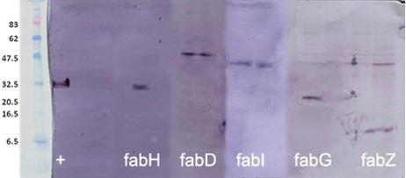

**Figure S-1.** Western blot analysis of purified fabH-6xHis, fabD-6xHis, fabI-6xHis, fabG-6xHis and fabZ-6xHis. The image was created from independent Western blot images. Relative sizes among enzymes are not to scale.

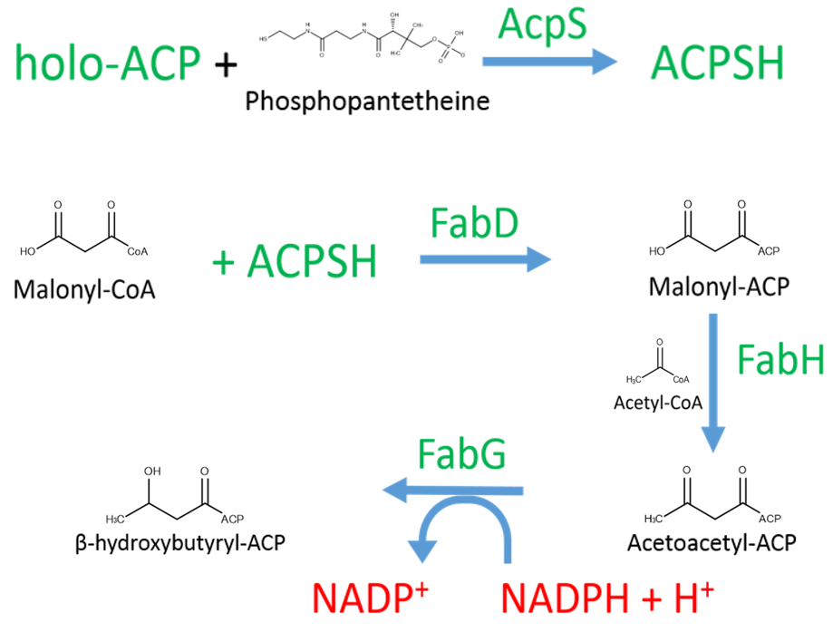

**Figure S-2.** Pathway for the production of β-hydroxybutyryl-ACP. The reduction of the keto group to alcohol requires NADPH as a reducing agent, and its depletion can be monitored.

**Integration Strategy**

1. B)

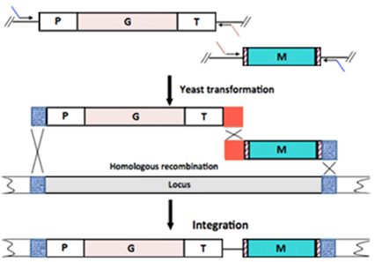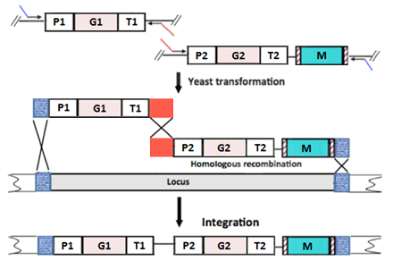

**Figure S-3.** Schematic comparison of the single gene and tandem gene integration. **A)** Double crossover integration of gene G into one locus. P1 is promoter P*PGK1* and T1 is terminator T*CYC1*. **B)** Integration of gene G1 and gene G2. P1 is P*PGK1*, P2 is P*TEF1*, T1 is T*CYC1*, and T2 is T*ADH2*. The construct P1-G1-T1 was obtained through PCR using a pXP219-based plasmid as template. The construct P2-G2-T2-M (e.g., M=*LEU2* marker) was obtained through PCR using a pRF320-based plasmid as template.

A)

B)

**Figure S-4. A)** Total fatty acids produced by strain BY8G after 24 h using thioesterase TEII, RC, and TesA.Control strains with empty vector (ev), BY4741+pXP219 (dotted) and BY6G+pXP219 (diagonal striped) are compared to strains BY8G+pXP219-TEII (horizontal striped), BY8G+pXP219-RC (squared), and BY8G+pXP219-tesA (brick). **B)** Fatty acid profile as % of the total FA produced by each strain described above. No C14 was detected for any of the samples. Results are expressed as mean ± error from two independent experiments.

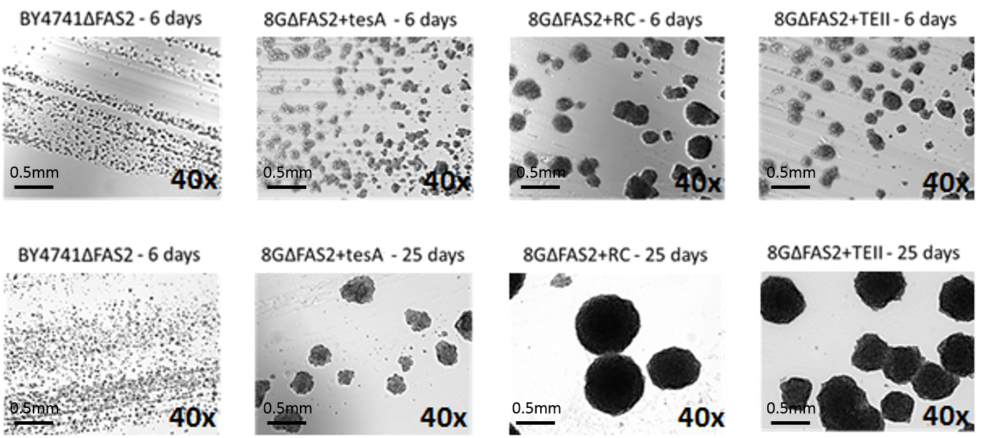

**Figure S-5***. In vivo* confirmation of heterologous *E.coli* FAS activity in strain BY8GFAS2 with different thioesterases: TesA, RC, and TEII. The negative control was strain BY4741FAS2 carrying an empty plasmid pXP219. The FAS2 strains were streaked on synthetic minimal media plates supplemented with fatty acids. Subsequent colonies were re-suspended in water, plated in the absence of FAs, and allowed to grow for 6 days (first row) and 25 days (second row). The images are 40xmagnificationbright-field microscopy pictures (Olympus, BX51).

**Figure S-6.** Growth curves for 8GΔFAS2+pXP219-RC (blue circles), 8G+pXP219-RC (grey triangles), and BY4741+pXP219 (orange squares) as a control. Cells were inoculated overnight in 5mL SDC(A), cells from those cultures were used to inoculate 50 mL SDC(A) at an initial OD600 of 0.1.